Priority List of Bridges Repaired
Priority (lowest is Top Priority) | County Location | Implementing Agency | Bridge Number from Inspection Report | Local Agency Bridge ID | Facility Carried | Feature Intersected | Location | Sufficiency Rating
1 | San Diego | County of San Diego | 57C-0002 | F47-B1 | Los Terrinetos Rd. | Sweetwater River | 0.1 mi w/o SR79 | 68.3
3 | San Diego | County of San Diego | 57C-0227 | J42-B2 | Old Highway 80 | Boundary Creek | 2 mi w/o Carrizo Gorge Rd. | 73.5
4 | San Diego | County of San Diego | 57C-0358 | 440-6504-B1 | Sycamore Drive | San Marcos Creek N Fork | .19 mi e/o Twin Oaks Valley Rd | 75.1
5 | San Diego | County of  San Diego | 57C-0335 | J42-B8 | Old  Highway 80 | Pine Valley  Creek | s/o Pine  Valley Creek  Rd | 72.9
6 | San Diego | County of  San Diego | 57C-0574 | 270-590-B1 | Riverford  Road | San Diego River | 0.1 mi n/o  SR67 | 96.2
7 | San Diego | County of  San Diego | 57C-0120 | E28-B1 | Willows  Road | Viejas Creek | 0.9 mi ne/o  I-8 | 74.4
8 | San Diego | County of  San Diego | 57C-0363 | C6-B2 | Mesa Grande  Rd | Santa Ysabel  Creek N Fk | 0.1 mi w/o  SR79 | 80
9 | San Diego | County of  San Diego | 57C-0375 | F20B-B1 | Honey  Springs Rd | Dulzura Creek  Tributary | 2.6 mi e/o  SR94 | 99.7
10 | San Diego | County of  San Diego | 57C-0158 | B8-1-B1 | Little  Gopher  Cnyn Rd | Gopher Canyon  Creek | 300' n/o  Gopher Cyn Rd (Previously Ormsby St) | 72.7
11 | San Diego | County of  San Diego | 57C-0553 | F12-B1 | Steel Cnyn  Rd | Sweetwater River | 0.2 mi s/o  Willow Glen | 89.2
12 | San Diego | County of  San Diego | 57C-0258 | F8-1-B3 | Japatul Road | Sweetwater River | e/o Tavern Rd | 98.2
13 | San Diego | County of  San Diego | 57C-0144 | C2-B1 | Lake  Wohlford Rd | Escondido Creek | 2 mi e/o  Valley Center  Rd | 78.2
14 | San Diego | County of  San Diego | 57C-0511 | 515-330-B1 | Lawrence  Welk Dr | Moosa Creek S  Fork | 0.15 mi e/o I-  15 | 77
15 | San Diego | County of  San Diego | 57C-0226 | J42-B1 | Old  Highway 80 | SD & AE  Railroad | 2.65 mi w/o  Carrizo Gorge  Rd | 89.7
16 | San Diego | County of  San Diego | 57C-0186 | E48-1-B1 | Alpine Blvd | Viejas Creek | 0.5 mi e/o  Alpine Blvd- Willows Rd | 96.9

Before and After Pictures
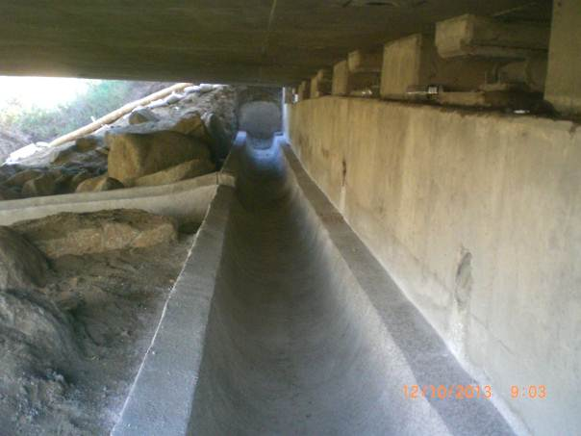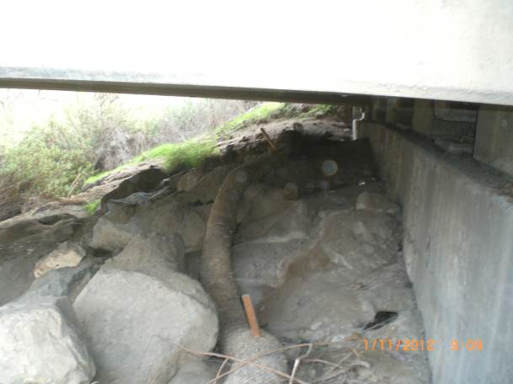
Riverford Bridge (After) Riverford Bridge (Before)

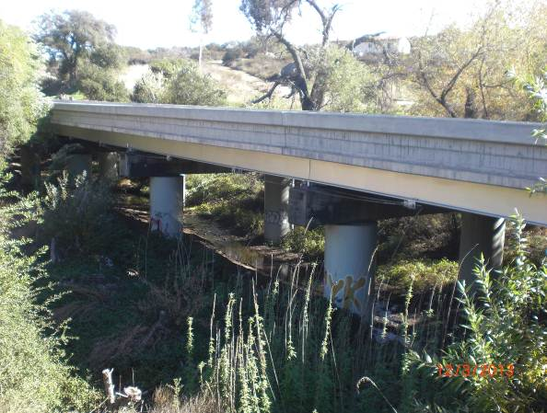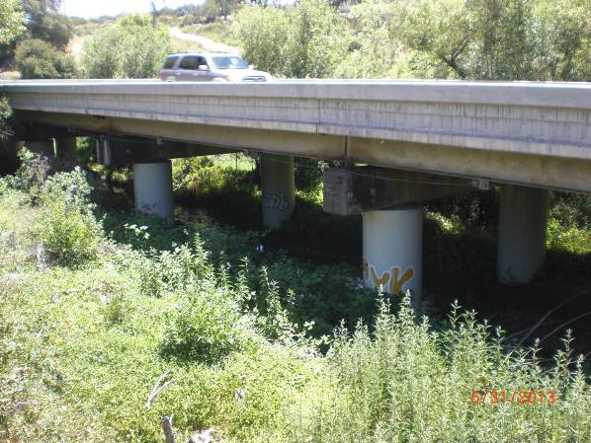
Willows Road Bridge (After) Willows Road Bridge (Before)
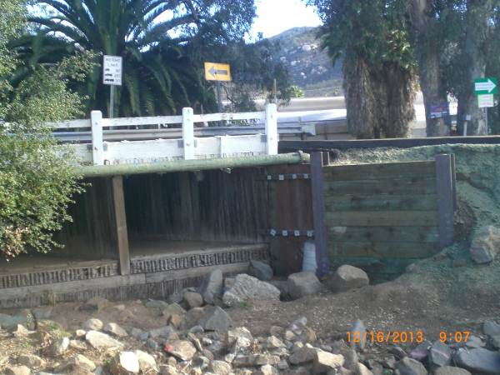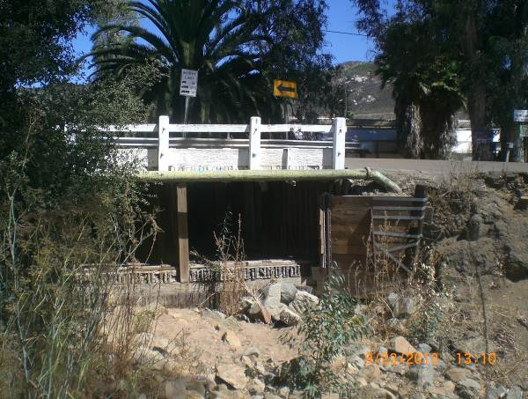
Sycamore Dr. Bridge (After) Sycamore Dr. Bridge (Before)

